## Chatswood CBD Planning and Urban Design Strategy

The original Chatswood CBD Strategy (the strategy) was approved at Council’s meeting of 26 June 2017 and finalised in January 2018. Council has prepared the strategy to guide all development in the Chatswood CBD over the next 20 years.

Key aims of the strategy to facilitate growth within the Chatswood CBD included:

* Expansion of the recognised CBD boundaries.
* Extension of the current B3 Commercial Core zone on the eastern side of the railway line further south of Albert Avenue.
* Prohibiting residential development in the CBD core.
* Permitting B4 Mixed Use development in all areas of the CBD outside the commercial core.
* Increasing building heights through the CBD subject to a solar access plane and Procedures for Air Navigation Services – Aircraft Operations (PANS-OPS) limits for Sydney Airport:
  + No max in the CBD core.
  + 90m in the B4 Mixed Use area.
* Facilitating a greater emphasis on sustainability and good design.
* Implementing a design review panel for development up to 35m and a competitive design process for development over 35m.

It is Council’s intent that the strategy will inform the preparation of future site-specific planning proposals within the Chatswood CBD to support the delivery of new job opportunities, housing growth and support and contribute to improved public domain outcomes.

The strategy will also assist Council in aligning its planning framework with other strategic planning work including its:

* Local Strategic Planning Statement (LSPS).
* Local Housing Strategy (LHS).
* Comprehensive LEP amendment.

The key aims of the strategy which are applicable to the subject site include:

* Maintaining the site’s B4 Mixed Use zone.
* Increasing the maximum height of buildings for the site to 90m.
* Increasing the maximum FSR for the site to 6:1 with a minimum commercial FSR requirement of 1:1.

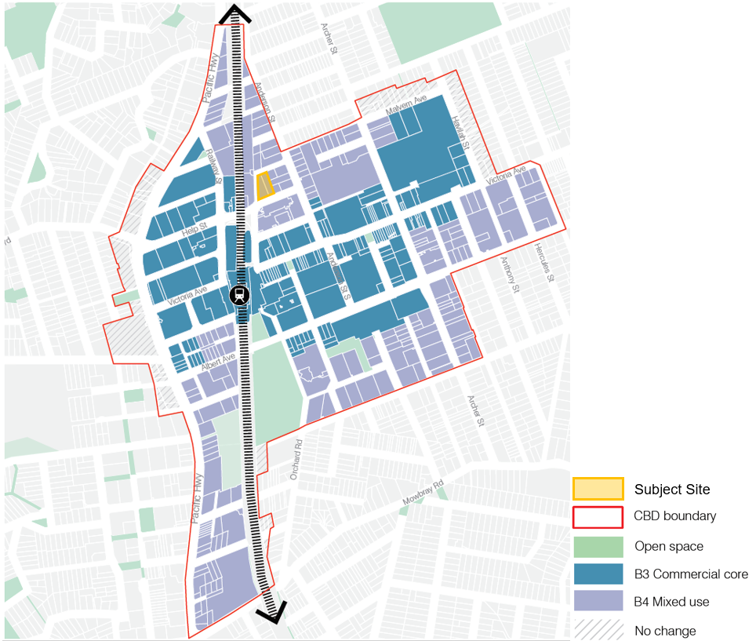

***Figure 1:*** *Proposed land use map under Chatswood CBD Strategy (source: Willoughby City Council).*

**Department’s Partial Endorsement of the Strategy**

On 9 August 2019, the Department issued a partial endorsement for the strategy **(Attachment G2)**.

The Department supported the intention of the strategy to promote and deliver additional commercial development, residential capacity and deliver good urban design outcomes within the CBD, but it was recognised that further work was also required to inform some of the strategy’s key approaches. This was especially the case for the proposed B4 Mixed Use areas on the periphery of the CBD (**Figure 1**).

Therefore, the partial endorsement of the strategy only applied to the B3 Commerical core Area. Additional work was required to be undertaken for the B4 Mixed Use area, which specifically required:

1. Council is to consult with the Department of Transport (formerly Transport for NSW and Roads and Maritime Services) regarding whether transport and traffic analysis is required to determine whether the growth anticipated by the full strategy can be accommodated by the current and future transport and road networks.
2. Council is to reconsider the proposed B4 Mixed Use zoning within the CBD periphery, including permitting a minimum 1:1 commercial floor space outcome for all mixed-use areas identifies within the strategy area is appropriate.
3. Council is to undertake a detailed built form analysis and assessment of building height and FSRs for land in the mixed-use areas identified in the strategy area. This work is to include:
   * A visual impact analysis to demonstrate how future built form in the strategy area will look along road and laneway streetscapes that form an edge to the strategy area.
   * An analysis of potential amenity impacts to the neighbouring low-density residential sites and heritage conservation areas.
4. Council is to only utilise appropriate mechanisms within the parameters of the Environmental Planning and Assessment Act 1979 for the provision of local infrastructure to support new development such revisions to its Section 7.12 or Section 7.11 Plans or inserting a new clause in Willoughby LEP 2012 for the delivery of on-site essential infrastructure. No value capture mechanism or the like will be supported by the Department.

**Chatswood CBD Strategy Supplementary Package**

On 30 March 2020, Council submitted the Chatswood CBD Strategy supplementary package to the Department for review. The package was developed in response to the Department’s partial endorsement conditions with the intention of allowing the Department to issue its full endorsement of the strategy.

The package was supported by:

* A transport and traffic methodology prepared by Arup.
* Economic advice for the B4 Mixed Use zones prepared by SGS.
* Chatswood precinct urban design study prepared by GMU.
* Chatswood heritage study prepared by Weir Phillips Heritage.

Following the Department’s assessment of the information submitted as part of the supplement package, the Department was supportive of Council’s preparation of a revised Chatswood CBD Strategy and provided its full endorsement subject to several recommendations.

**Department’s Full Endorsement**

On 9 July 2020, the Department issued its full endorsement of the Chatswood CBD strategy **(Attachment G3)** subject to the following recommendations for Council to consider in its preparation of its final strategy:

* Council is to continue progressing its traffic and transport study with Arup and Transport for NSW.
* Council should consider minimum non-residential FSR’s for any land in the B4 Mixed Use area which obtains a max FSR of less than 6:1.
* Council is to implement the built form recommendations as suggested by GMU into its revised strategy.
* Council should consider if a minimum lot size of 1,200sqm for the B4 Mixed Use area is sufficient.
* Council should continue the progression and finalisation of its Chatswood CBD public realm strategy.
* Council should implement the heritage interface recommendations as suggested by Weir Phillips.

**Council’s Final Strategy**

On 14 September 2020, Council adopted its final Chatswood CBD Strategy   
**(Attachment G4)** following amendments to the original strategy as recommended by the Department. The final strategy proposes no changes to the subject site from the original strategy.